My Aussie Crush – fake messages to get the reader to buy more message credits.
Read the message from “Slip098knot” where she claims that “we’re both from Penrith”. Then when the reader clicks on her image or ‘name’, the next screen is her profile, and guess what, she’s not from Penrith NSW, but Albany, WA – the other side of the country!
Here’s the message from this ‘bait’ sender:
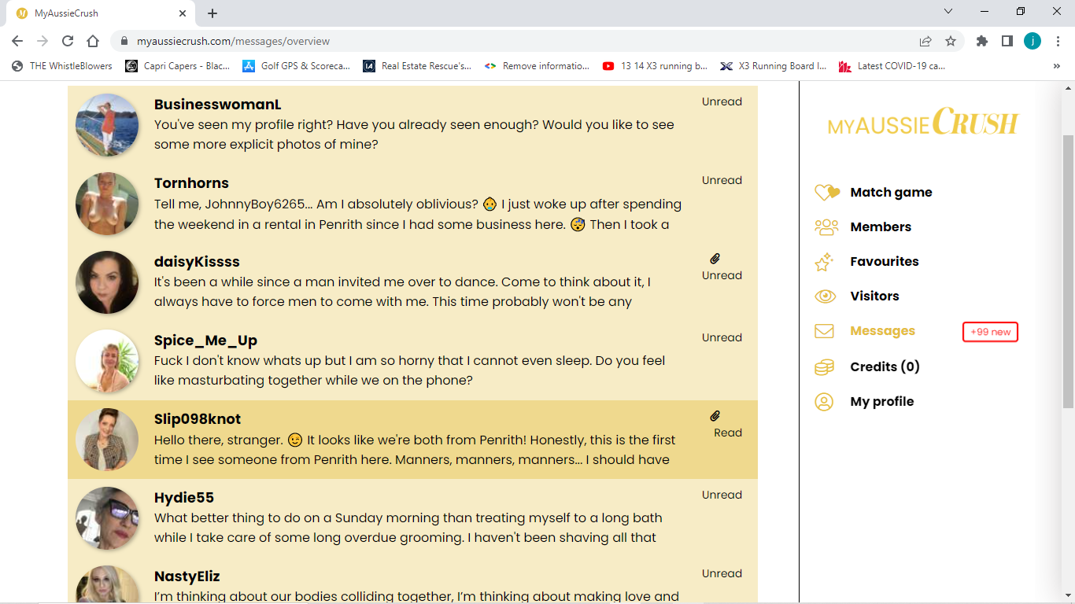
Now here’s the messenger’s profile:
